
School Of Future Tech

Case Study Report On:
ParkPoint
On-Demand Driveway Parking

By
Ashutosh Pawar
150096725130

Index
- Introduction to the Case Study.
- Problem Statement / Case Background (Abstract).
- Problem Statement / Case Study Design.
- Methods & Algorithms Technology Applied in the Problem Statement / Case Study.
- Problem Statement / Case Study Implementation Details and Snapshots.
- Problem Statement / Case Study Results and Conclusion.
- References

1. Introduction to the Case Study
Urban parking is one of the most persistent infrastructure challenges in Indian metropolitan cities. In Mumbai alone, the vehicle-to-parking-space ratio is heavily skewed, leading to congestion, illegal roadside parking, and wasted time for commuters. Meanwhile, thousands of private driveways and garage spaces sit idle during working hours.
ParkPoint is a web-based MVP (Minimum Viable Product) that bridges this gap by enabling urban drivers to discover, filter, and book private driveway parking spaces in real-time using an interactive map. The project falls under the domains of Smart Cities and the Sharing Economy, applying web technologies to solve a real-world urban mobility problem.
This case study documents the end-to-end design, development, and implementation of ParkPoint using front-end web technologies — HTML5, CSS3, and Vanilla JavaScript — with Leaflet.js as the mapping engine.

2. Problem Statement / Case Background (Abstract)
Finding parking in densely populated urban areas like Mumbai is time-consuming, stressful, and often results in illegal parking. Existing solutions (malls, municipal lots) are limited in number, expensive, and not distributed across residential neighborhoods.
The core problem ParkPoint addresses is:
"How can private, underutilized driveway and garage spaces be made discoverable and bookable for urban drivers in real-time?"
ParkPoint solves this by presenting a map-based interface where drivers can:
- View available parking spots across Mumbai plotted on a live map.
- Filter spots by criteria such as EV charging availability, large vehicle access, and price range.
- Search for spots by locality name.
- View dynamic pricing that adjusts during peak hours.
- Book a spot with a time-limited reservation hold and multiple payment options.
The MVP demonstrates the feasibility of a peer-to-peer parking marketplace using only client-side technologies and mock data.

3. Problem Statement / Case Study Design

3.1 System Architecture
ParkPoint is a purely front-end application with no server or database. All data is stored in a JavaScript array (mock database), and the app runs entirely in the browser.
File Structure:
File | Purpose
index.css | All styles (layout, components, responsive design)
data.js | Mock database (array of parking spot objects)
map.html | Main page (interactive map with overlays)
map.js | Map logic (markers, filters, search, pricing)
booking.html | Booking page (timer, pricing breakdown, payment)
booking.js | Booking logic (timer, confirmation flow)

3.2 Data Model
Each parking spot is stored as a JavaScript object with the following fields:
Field | Type | Description
id | String | Unique identifier (e.g., "spot_001")
name | String | Human-readable spot name
lat, lng | Number | Geographic coordinates
amenities | Array | List of features (EV Charging, CCTV, etc.)
basePrice | Number | Hourly rate in INR
sizeLimit | String | Maximum vehicle size (Hatchback/Sedan/SUV)
hasEV | Boolean | Has EV charging station?
hasLargeAccess | Boolean | Can large vehicles enter?
locality | String | Area name (used for search filtering)
rating | Number | Average user rating out of 5

3.3 Page Flow
- User opens map.html and sees all parking spots on an interactive map.
- User clicks a marker — the left panel shows spot details, the right card shows the price.
- User can filter spots using checkboxes (EV, Large Vehicle, Low Price) or search by locality.
- User can toggle Peak Hours to see 1.5x pricing.
- User clicks "Book Spot" — navigates to booking.html with the spot ID and peak status in the URL.
- Booking page shows a 5-minute countdown timer, pricing breakdown, and payment options.
- User selects a payment method and clicks "Confirm Booking" to see the success overlay.

4. Methods & Algorithms / Technology Applied

4.1 Technology Stack
Layer | Technology | Purpose
Structure | HTML5 | Semantic page layout
Styling | CSS3 (Flexbox, Grid) | Dark-themed responsive UI
Logic | Vanilla JavaScript | All interactivity and data handling
Mapping | Leaflet.js + OpenStreetMap | Interactive map rendering
Icons | FontAwesome 6 | UI icons throughout the app
Fonts | Google Fonts (Inter) | Clean, modern typography

4.2 Peak Pricing Algorithm
The price displayed to the user is calculated using this formula:
FinalPrice = BaseRate x (isPeak ? 1.5 : 1.0)
In code:
function calculatePrice(baseRate) {
if (isPeak) {
return Math.round(baseRate * 1.5);
} else {
return baseRate;
}
}
The isPeak variable is controlled by a toggle switch on the map page. When enabled, all displayed prices are multiplied by 1.5x.

4.3 Filter Algorithm
The filter system uses a simple loop-and-check approach. It iterates through all parking spots and keeps only those that match the selected filters:
- If "EV Friendly" is checked, spots without EV charging are removed.
- If "Large Vehicle" is checked, spots without large vehicle access are removed.
- If "Low Price" is checked, spots with basePrice > 100 are removed.
- If search text is entered, spots whose locality or name do not contain the text are removed.
This function is called whenever any filter checkbox changes or the user types in the search box. The map markers are then re-rendered with only the matching spots.

4.4 Reservation Timer (localStorage Persistence)
The booking page implements a 5-minute countdown using setInterval(). To prevent the timer from resetting on page refresh, the start time is saved in localStorage:
- On first visit, the current timestamp is saved to localStorage.
- On each tick (every 1 second), the elapsed time is calculated by subtracting the saved timestamp from the current time.
- The remaining seconds are displayed in MM:SS format.
- The timer color changes: green (normal), amber (under 2.5 min), red (under 1 min).
- When it reaches zero, the user is alerted and redirected back to the map.

4.5 Custom Map Markers
Instead of using default Leaflet marker images, ParkPoint uses CSS-styled L.divIcon markers:
- Default state: Grey teardrop-shaped pin with a white center dot.
- Selected state: Green pin with a glow/shadow effect.
- This is achieved by toggling an .active CSS class on the marker's DOM element when clicked.

5. Implementation Details and Snapshots

5.1 Map Page (map.html)
The map page consists of the following components:
- Map: Full-screen Leaflet map
- Tiles: Dark CARTO tiles centered on Mumbai (19.076N, 72.877E).
- Top Bar: Pill-shaped bar with filter dropdown (left) and search input (right).
- Left Panel: Slides in on marker click; shows name, rating, amenities, Google Maps link, Book button.
- Price Card: Floating card showing hourly rate in INR with peak pricing label.
- Peak Toggle: Bottom-right switch to enable/disable 1.5x peak pricing.

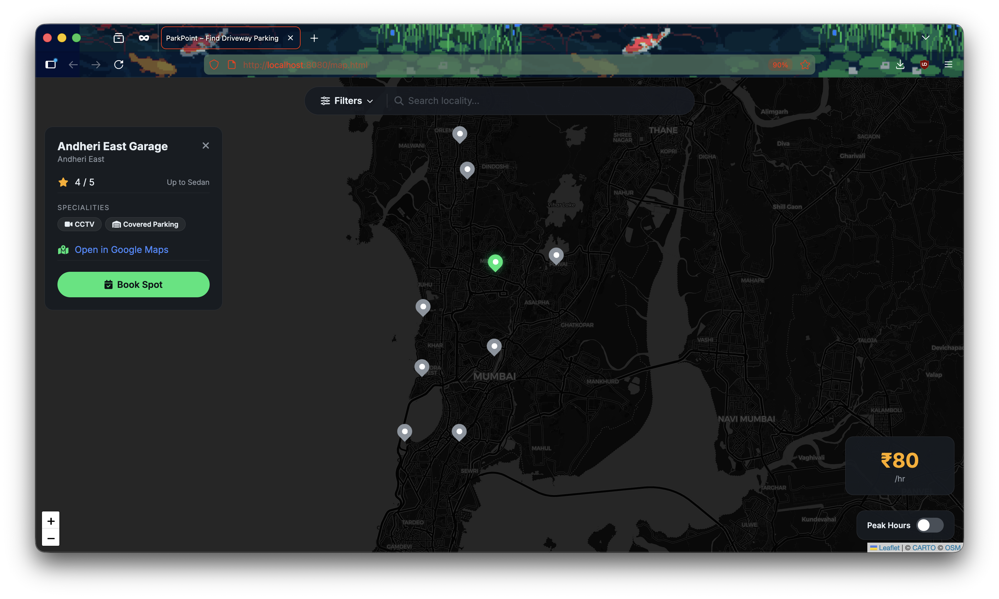
[screenshot of map page with a marker selected, showing the left panel and price card]
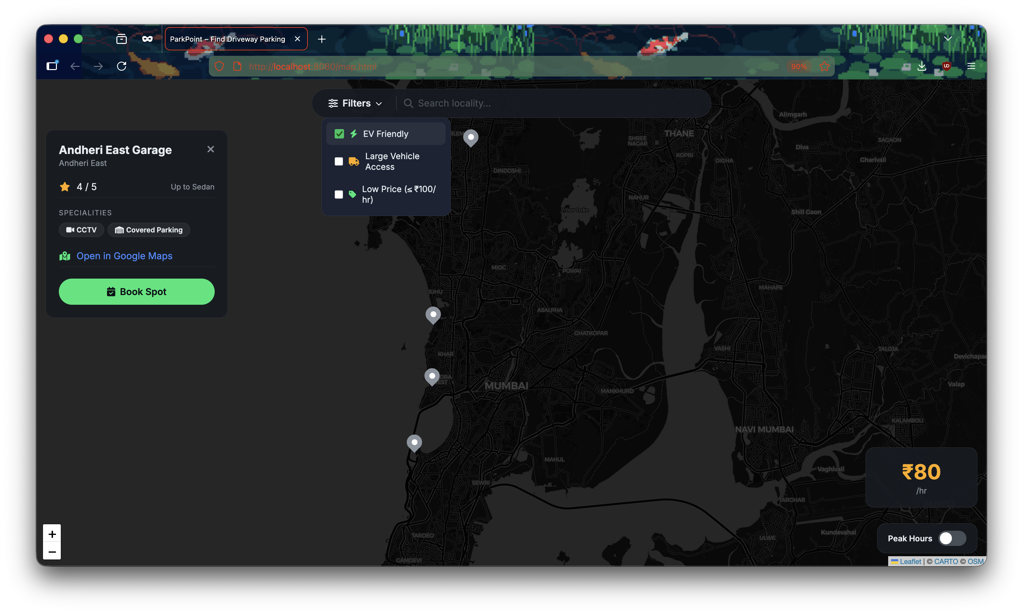
[screenshot of the filter dropdown open with EV Friendly checked]

5.2 Booking Page (booking.html)
The booking page consists of the following components:
- Header: Spot name pulled from mock data using URL parameter.
- Countdown Timer: Large MM:SS display that changes color as time runs out.
- Pricing Table: Shows base rate, peak multiplier (if applicable), and total.
- Payment Options: Three clickable cards: UPI, Card, FASTag.
- Confirm Button: Disabled until a payment method is selected.
- Success Overlay: Full-screen overlay with booking summary after confirmation.
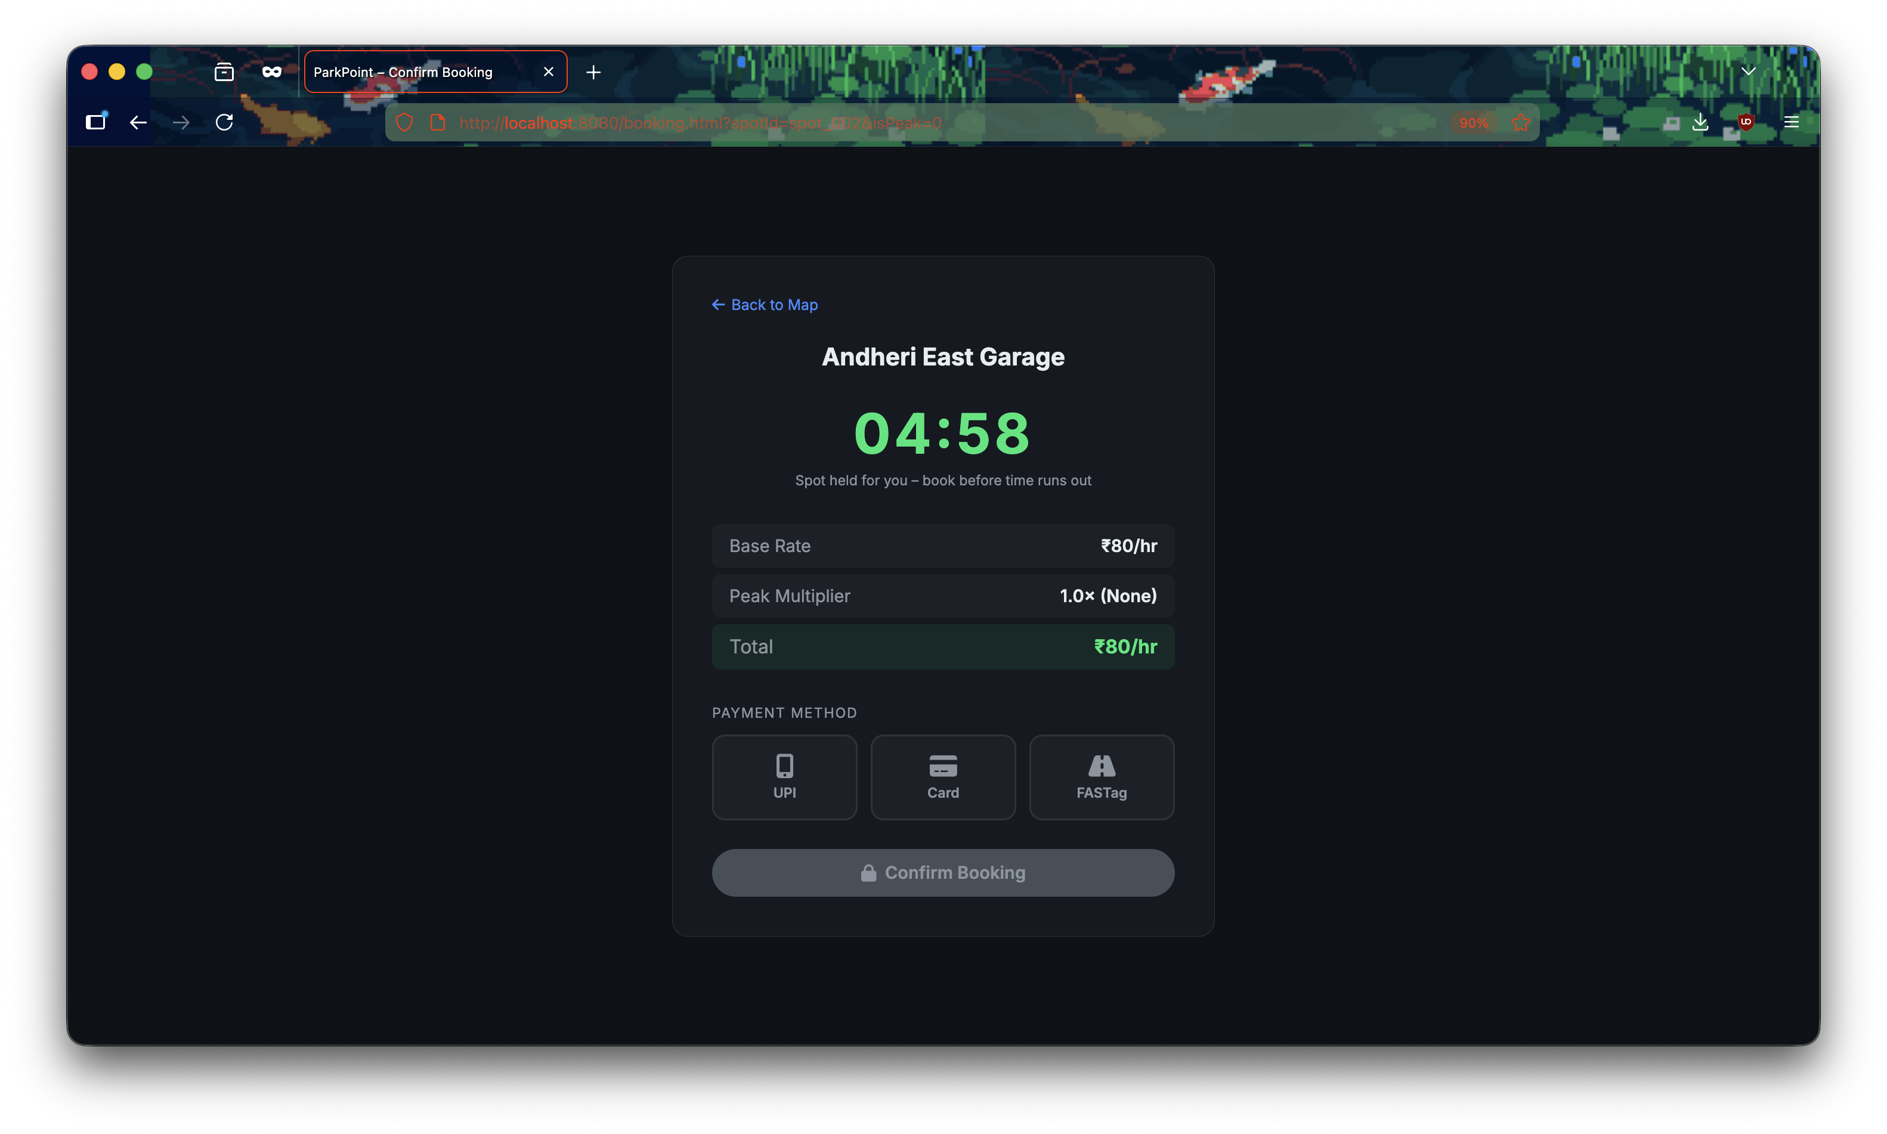
[screenshot of booking page showing the timer and pricing table]
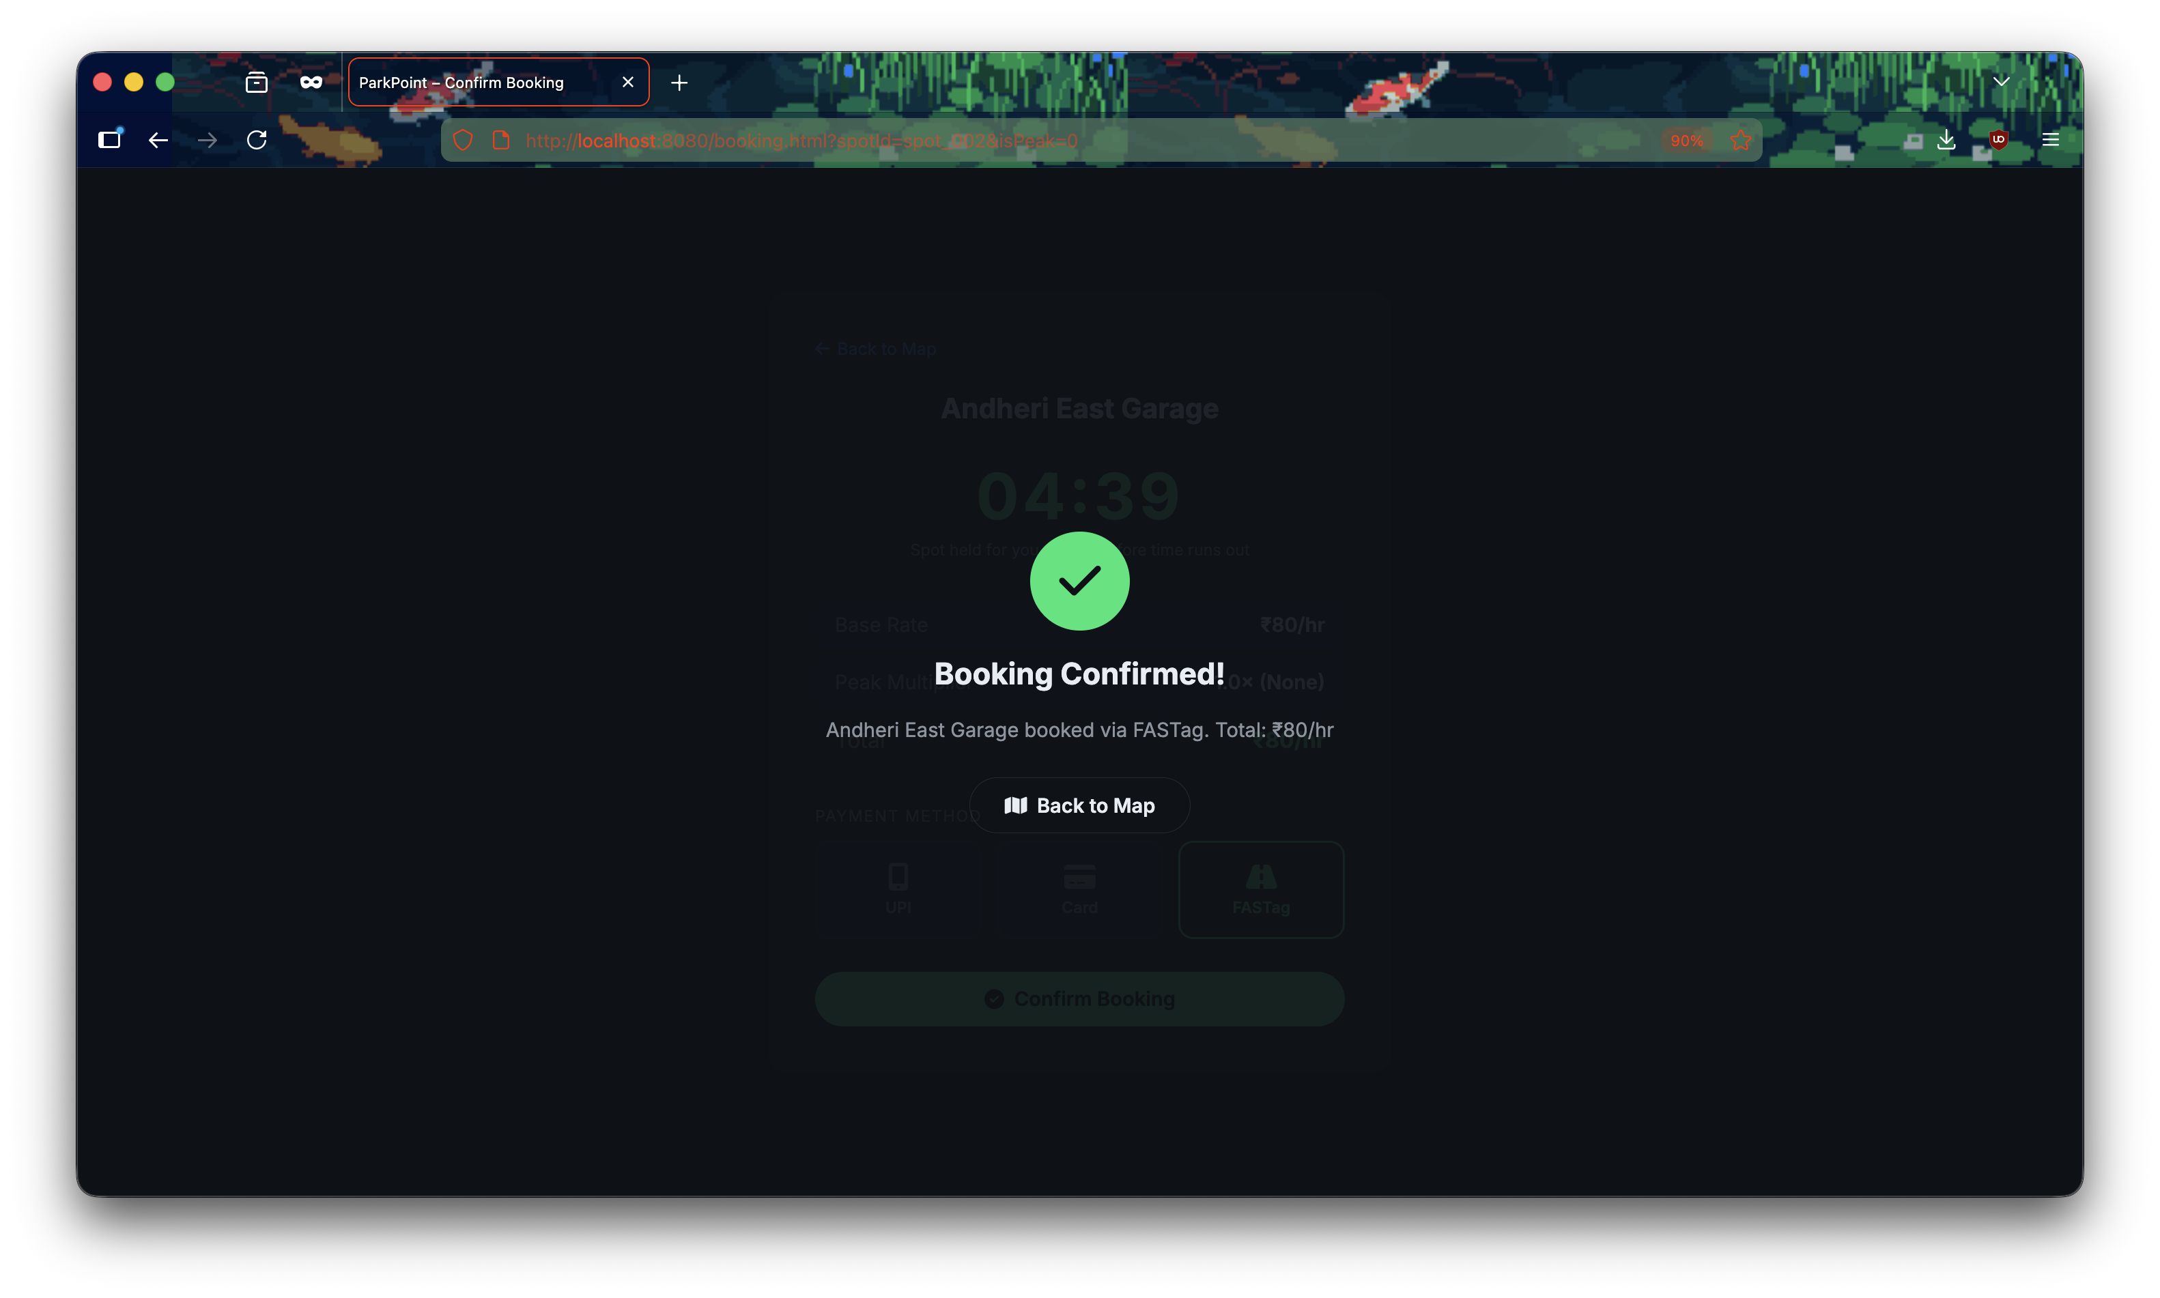
[screenshot of the success overlay after confirming a booking]

6. Results and Conclusion

6.1 Results
The ParkPoint MVP successfully demonstrates all required features:
Feature | Status | Description
Interactive Map | Working | Leaflet.js map with 10 custom markers across Mumbai
Spot Selection | Working | Click marker to see details, pin turns green
Filter System | Working | EV Friendly, Large Vehicle, Low Price filters
Locality Search | Working | Real-time search by area name
Peak Pricing | Working | Toggle applies 1.5x multiplier to all prices
Reservation Timer | Working | 5-min countdown persists across page refreshes
Payment Selection | Working | UPI, Card, FASTag options with visual feedback
Booking Confirmation | Working | Success overlay with booking summary
Responsive Layout | Working | Adapts to mobile screens (768px and below)

6.2 Limitations
- No real backend — all data is hardcoded in a JavaScript array.
- No user authentication — there is no login/signup system.
- No real payment processing — payment selection is visual only.
- Static availability — spots are always shown as available.

6.3 Future Scope
- Integration with a backend (Node.js/Express + MongoDB) for persistent data.
- User authentication and profile management.
- Real-time spot availability using WebSocket connections.
- Actual payment gateway integration (Razorpay, Stripe).
- Host/owner dashboard for listing private driveways.
- GPS-based navigation to the booked spot.
- Rating and review system for spots.

6.4 Conclusion
ParkPoint demonstrates that a functional, visually polished parking marketplace prototype can be built using only front-end web technologies. The project applies core JavaScript concepts — DOM manipulation, event handling, localStorage, URL parameters, and setInterval — to solve a tangible urban problem.
The interactive map powered by Leaflet.js and OpenStreetMap provides a realistic user experience without any paid API dependencies. This MVP serves as a strong foundation that can be extended into a full-stack application for real-world deployment.

7. References
1. Leaflet.js — Open-source JavaScript library for interactive maps. https://leafletjs.com/
2. OpenStreetMap — Free, editable map data. https://www.openstreetmap.org/
3. CARTO Basemaps — Dark-themed map tile provider. https://carto.com/basemaps/
4. FontAwesome — Icon library for web UI. https://fontawesome.com/
5. Google Fonts (Inter) — Open-source typeface. https://fonts.google.com/specimen/Inter
6. MDN Web Docs — localStorage. https://developer.mozilla.org/en-US/docs/Web/API/Window/localStorage
7. MDN Web Docs — setInterval. https://developer.mozilla.org/en-US/docs/Web/API/setInterval
8. MDN Web Docs — URLSearchParams. https://developer.mozilla.org/en-US/docs/Web/API/URLSearchParams
9. W3Schools — CSS Flexbox. https://www.w3schools.com/css/css3_flexbox.asp
10. W3Schools — CSS Grid. https://www.w3schools.com/css/css_grid.asp
11. StackOverFlow QnA threads
12. Gemini CLI

